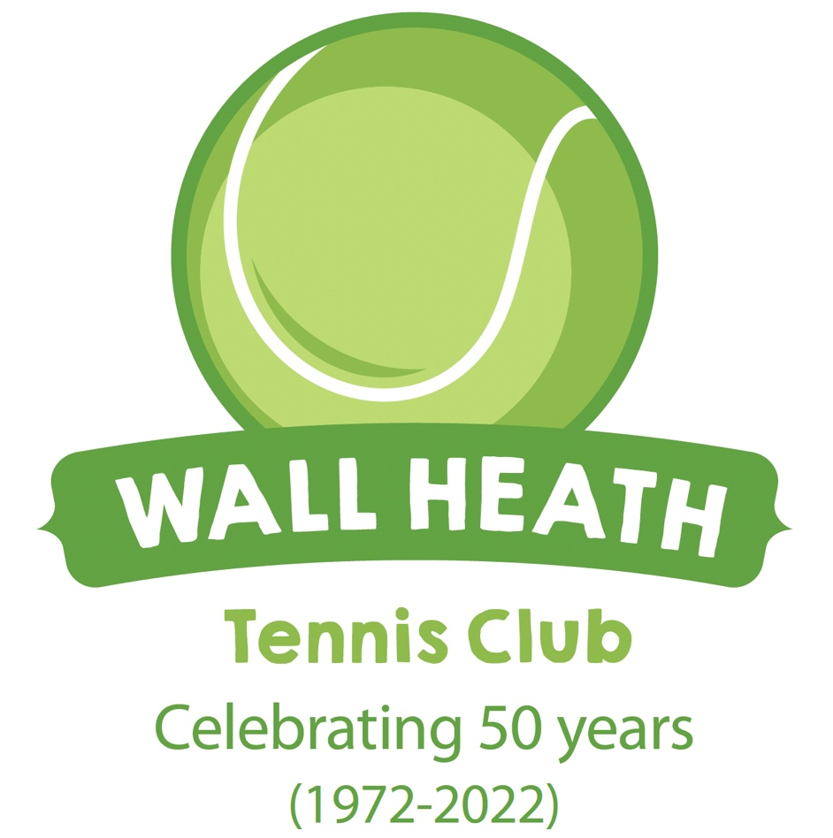

Danny Sapsford GB Davis Cup and Wimbledon player says Wall Heath TC is a great community club for local families.

For more information and booking courts visit : [https://clubspark.lta.org.uk/WallHeathTennisClub/](https://clubspark.lta.org.uk/WallHeathTennisClub/s)

‘It’s a great place to play and meet friendly people.’

Paul

**Wall Heath Tennis Club**

**FREE Open Day**

**Saturday 13April 9.30-1pm**

**(see sessions below but come anyway if those times don’t suit)**

**Free tennis with hot butties and drinks for all.**

**(Pickleball and Walking tennis on offer too).**

Contact Adrian

At

[adrianhyde1@virginmedia.com](mailto:adrianhyde1@virginmedia.com)

**or 07753673143**

**Wall Heath Community Centre, Enville Road**

**DY6 0JT**

**FREE** Tennis and Pickleball for all ages.

Saturday 13 April (9.30 – 1pm)

9.30am – 10.30am – primary age (parents can play too)

10.40 am – 11.40am – Secondary age (parents can play too)

11.45 – 1pm – Adult tennis, pickleball and walking tennis. (children can play too)

Lots of fun games for the children and opportunities for parents to play tennis, pickleball and walking tennis. Free hot butties and drinks too.

Information on our tennis programme and opportunities plus great membership offers.

- **Pickleball is an increasingly popular racket sport which can be played by all ages and all levels of player. It is very popular with senior players as the court is much smaller. Give it a try for free.**

* **Walking tennis is also becoming increasingly popular with senior players as its rules give players more time to rally (free).**

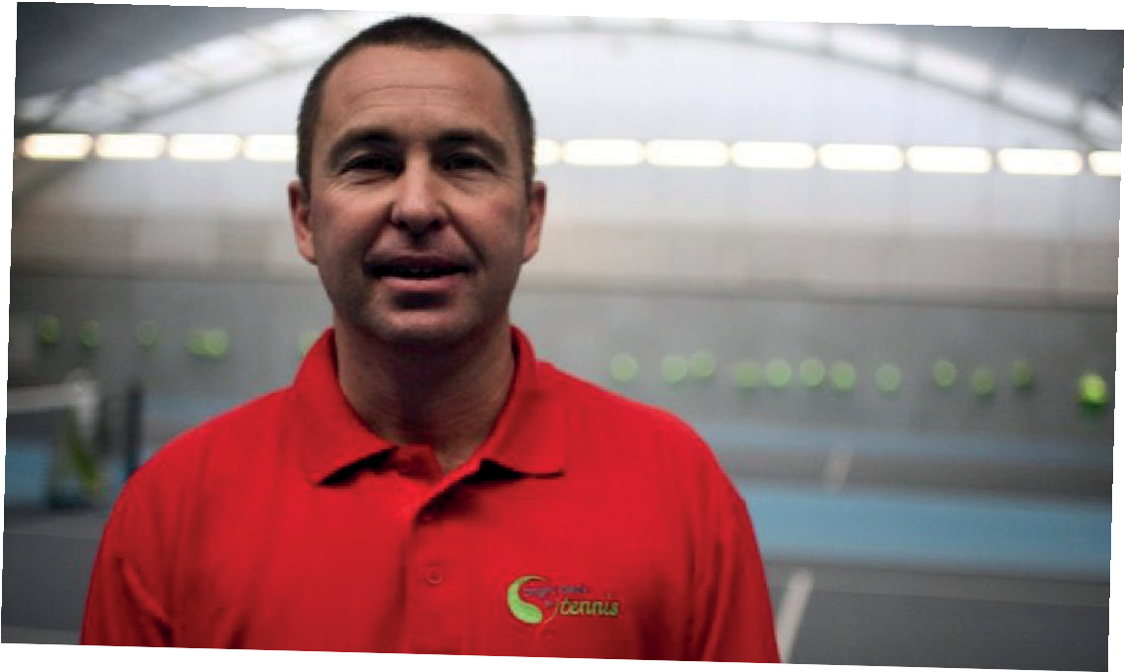

H

E

A

T

H

W

A

L

L